Jordan Thomas

CYBR410 2233-1

February 1, 2023

# Showing the tables in the pysports database:

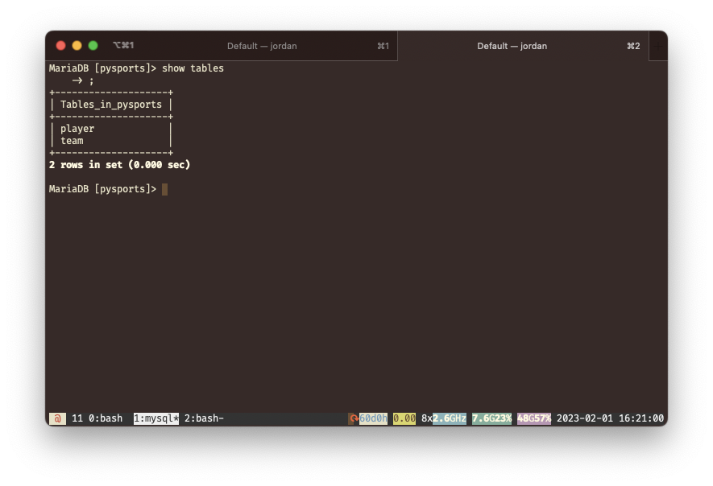

# Python successfully connected to MySQL database

My GitHub for this week is located at https://github.com/TidOS/csd-310/tree/master/module_8